 | RIVER VALLEY HIGH SCHOOL  YEAR 6 PRELIMINARY EXAMINATION

H2 CHEMISTRY |  | 9647/02
Paper 2 Structured Questions
Suggested Answers

1 | (a) | 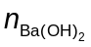required = 0.100 × 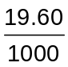  = 0.00196 mol  Ba(OH)₂ ≡ 2RCOOH  n_{RCOOH} used = 0.00196 × 2  = 0.00392 mol  M_{r} of A = 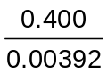  = 102
 | (b) | pV = nRT  (101 × 10³)(92.0 × 10⁻⁶) = n_{C}(8.31)(50 + 273)  n_{C} = 0.00346 mol  M_{r} of C = 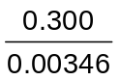  = 86.7
 | (c) | n_{D} = 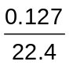  = 0.00567 mol  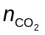= 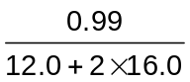  = 0.0225 mol  Number of C atoms in 1 molecule of D = 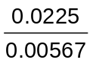  = 3.97  ≈ 4  Hence molecular formula of D is C₄H₁₀.  (general formula of an alkane is C_{n}H_{2n+1})
 | (d) | A: | CH₃CH₂CH₂CH₂COOH
 |  | B: | CH₃CH₂COOH
 |  | C: | CH₃CH₂CH₂CH₂CH₂CH₃
 |  | D: | CH₃CH₂CH₂CH₃
 |  | E: | CH₃CH₂CH₂CH₂CH₂CH₂CH₂CH₃
 | (e) | hydrogen bond  δ−  δ+  δ+  δ−  δ+  δ+  δ−  δ−  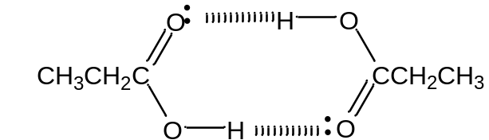
When B is in its liquid state, dimerisation occurs whereby hydrogen bonds are formed between the two acid molecules as shown in the diagram. Hence, the molecular mass is almost twice the molecular mass of a single acid molecule.
However, when acid B is in its aqueous state, there is a much bigger proportion of water molecules compared to acid molecules and hydrogen bonds are formed between the acid molecules and water molecules instead, hence the molecular mass is that of a single acid molecule.
 | (f) | CH₃COOH has the highest pK_{a} and is the weakest acid as the methyl group is electron donating and intensifies the negative charge of the COO⁻ group, making the ethanoate anion the least stable.  C₆H₅COOH has a lower pK_{a} than CH₃COOH as the negative charge of the COO⁻ group is delocalised into the benzene ring, making the benzoate anion more stable than the ethanoate anion.  CCl₃COOH has the lowest pK_{a} and is the strongest acid as the electron-withdrawing Cl atoms disperses the negative charge of the COO⁻ group, making the CCl₃COO⁻ anion the most stable.

2 | (a) | (i)  pure copper  CuSO₄(aq)  impure copper scrap | 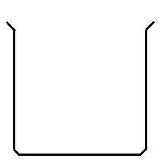
 |  | (ii) | Cu(s) → Cu²⁺(aq) + 2e⁻  (state symbols not required)  Cu²⁺ is continuously replenished by the dissolving copper scrap.
 | (b) | n_{Cu} = 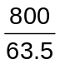  = 12.6 mol  Cu ≡ 2e⁻  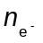 required = 2 × 12.6  = 25.2 mol  Total charge passed = 25.2 × 96500 = 2.43 × 10⁶ C  Q = I t ⇒ t = 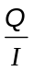  Time required for extraction = 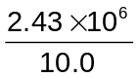  = 2.43 × 10⁵ s  = 2.81 days
 | (c) | E(Fe²⁺(aq)/Fe(s)) = −0.44 V  E(Cu²⁺(aq)/Cu(s)) = +0.34 V  E(Cu²⁺(aq)/Cu(s)) is more positive than E(Fe²⁺(aq)/Fe(s)), hence Cu²⁺ is preferentially reduced over Fe²⁺.
 | (d) | (i) | Al³⁺, Pb²⁺
 |  | (ii) | Any one of the following:  - Add any soluble chloride or sulfate (e.g. HCl, H₂SO₄) to the filtrate. The formation of a white ppt indicates presence of Pb²⁺(aq), while Al³⁺(aq) does not give any ppt.  - Add any soluble carbonate (e.g. Na₂CO₃) to the filtrate. The formation of a white ppt with effervescence (of colourless odourless gas which gives a white ppt with limewater) indicates presence of Al³⁺(aq), while Pb²⁺(aq) gives a white ppt only. (Recall that a solution of Al³⁺ is acidic due to hydrolysis.)  - Add any soluble chromate(VI) (e.g. K₂CrO₄) to the filtrate. The formation of a yellow ppt indicates presence of Pb²⁺(aq), while Al³⁺(aq) turns the yellow solution of chromate(VI) to orange.  - Add any soluble iodide (e.g. KI) to the filtrate. The formation of a yellow ppt indicates presence of Pb²⁺(aq), while Al³⁺(aq) does not give any ppt.

 | (e) | Cu(s) +  O₂(g) CuO(s)  ΔH_{f}  Cu(g) + O(g)  +305 +  (496)  Cu²⁺(g) + O²⁻(g)  +745 + (+1960)  + (−142) + (+844)  −155  ΔH_{f}(CuO) = 305 + 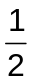 (496) + (+745) + (+1960) + (−142) + (+844) + (−155)  = 3805 kJ mol⁻¹

3 | (a) | Ba(NO₃)₂(s) → BaO(s) + 2NO₂(g) + O₂(g)
 | (b) | Mg²⁺ is smaller and has a higher charge density than Ba²⁺, hence Mg²⁺ has a greater polarising power and weakens the N−O bonds in the NO₃⁻ anion to a greater extent. Consequently, Mg(NO₃)₂ decomposes at a lower temperature than Ba(NO₃)₂.
 | (c) | BaCO₃ reacts with the acid in the stomach to form soluble Ba²⁺.

4 | (a) | (i) | N₂(g) + 3H₂(g)  2NH₃(g)  (state symbols not required)
 |  | (ii) | 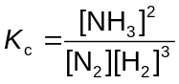
 |  | (iii) | 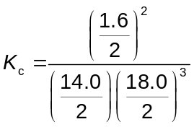  = 1.25 × 10⁻⁴ mol⁻² dm⁶
 |  | (iv) | The activation energy of the reaction is very high as the NN (triple) bond is very strong / has a high bond energy.  (Finely divided) iron /iron(III) oxide / ruthenium
 |  | (v) | There is a decrease in the number of gaseous particles, hence decrease in disorder and ΔS < 0.  Using ΔG = ΔH − TΔS, as temperature increases, the −TΔS term increases/becomes more positive and  ΔG increases/becomes more positive.
 | (b) | (i) | Electrophilic substitution  (Generation of electrophile) HNO₃ + 2H₂SO₄ → NO₂⁺ + H₃O⁺ + 2HSO₄⁻  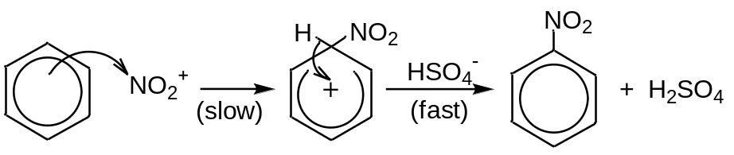
 |  | (ii) | 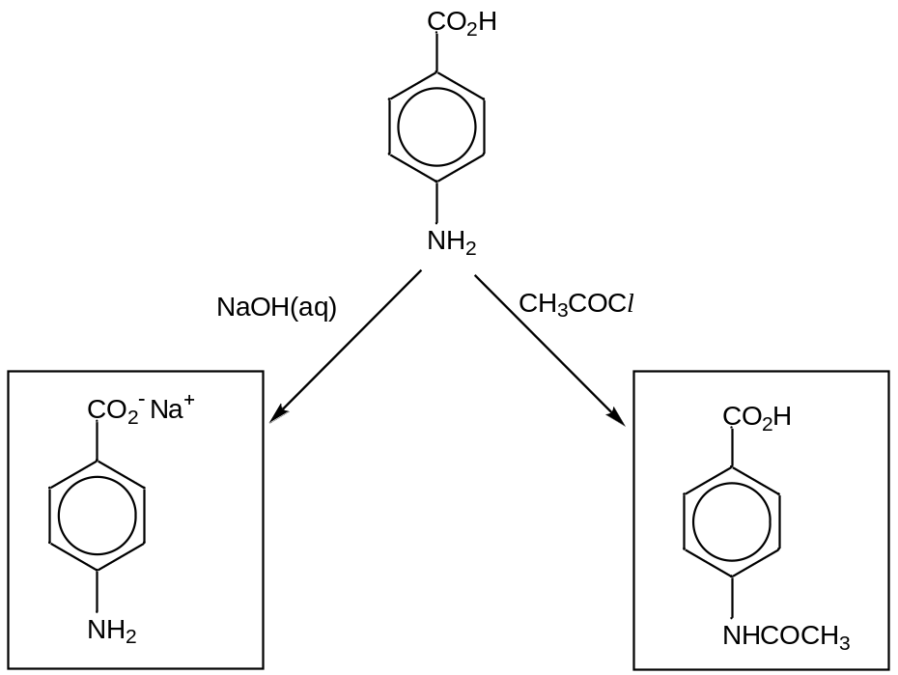
 | (c) | (i) | Optical isomerism
 |  |  | 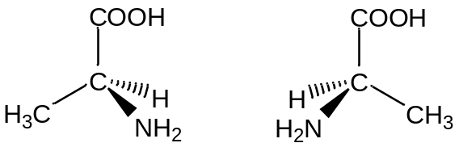
 |  | (ii) | 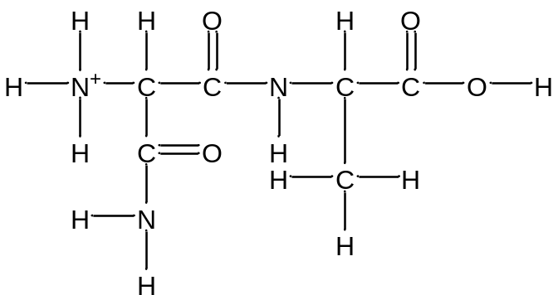  or  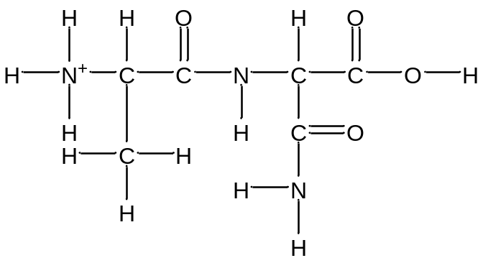
 |  | (iii) | Any one of the following:  - Add neutral FeCl₃(aq). Purple colouration is formed with tyrosine, while no purple colouration is formed with alanine.  - Add Br₂(aq). Reddish brown Br₂ is decolourised with tyrosine, while no decolourisation with alanine.  - Add acidified KMnO₄(aq) and heat. Purple KMnO₄ is decolourised with tyrosine, while no decolourisation with alanine.

5 | (a) | To distinguish jasmonic acid from the rest, use any one of the following tests:  - Add Na₂CO₃(aq). Effervescence (of a colourless odourless gas which gives a white ppt with limewater) occurs with jasmonic acid, but no gas is evolved with methyl jasmonate and jasmone.  - Add Na. Effervescence (of a colourless odourless gas which extinguishes a lighted splint with a ‘pop’ sound) occurs with jasmonic acid, but no gas is evolved with methyl jasmonate and jasmone.  - Add PCl₅ or SOCl₂. White fumes formed with jasmonic acid, but no white fumes with methyl jasmonate and jasmone.  To distinguish methyl jasmonate from the rest:  - Add acidified K₂Cr₂O₇(aq) and heat. Orange solution of K₂Cr₂O₇ turns green with methyl jasmonate, but K₂Cr₂O₇ remains orange for jasmonic acid and jasmone.
 | (b) | CH₃OH with a few drops of concentrated H₂SO₄, heat under reflux
 | (c) | Methyl jasmonate is more volatile.  Less energy is required to overcome the weaker van der Waals’ forces between methyl jasmonate molecules than the stronger hydrogen bonding between jasmonic acid molecules.

6 | (a) | the independent variable: identity of Group I hydroxide  the dependent variable: temperature rise/change  the other variable to be controlled: volume/mass of water
 | (b) | 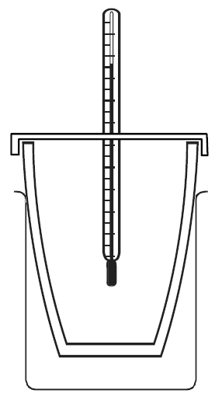  (beaker)  polystyrene cup  thermometer  (lid)  reaction mixture
Any two of the following:
S/N | Source of error | Improvement
1 | Some of the solid hydroxide may have absorbed water vapour and dissolved in it.  (This will result in a lower temperature rise. Hence the calculated heat evolved will lower than actual and the ΔH_{soln} determined will be less exothermic than actual.) | Keep the weighed solid in a closed container or use the solid hydroxide as soon as it is weighed to minimise exposure to water vapour in air.
2 | Heat is lost to the surroundings.  (This will result in a lower temperature rise. Hence the calculated heat evolved will be lower than actual and the ΔH_{soln} determined will be less exothermic than actual.) | Conduct the experiment in a draught-free room to reduce heat loss. or  Use a vacuum flask to contain the solution to reduce heat loss (due to conduction and radiation).  (If a lid is not used in the set-up above, a lid can be used to cover the cup to reduce heat loss (due to convection).)
3 | The temperature rise may be too small which results in a large percentage error in the measurement of the temperature change.  (The calculated heat evolved and ΔH_{soln} determined will be inaccurate.) | Use a larger mass of hydroxide or smaller volume of water.
4 | The thermometer used may be of low precision.  (This will result in an inaccurate temperature rise measured. Hence the calculated heat evolved and ΔH_{soln} will be inaccurate.) | Use a more precise thermometer to allow temperature to be read to a greater degree of precision.
5 | The mass of solid hydroxide measured may not be accurate due to the low precision of the weighing balance used. or  The volume of water measured may not be accurate due to the low precision of the measuring cylinder used.  (This will result in an inaccurate temperature rise. Hence the calculated heat evolved and ΔH_{soln} will be inaccurate.) | Use a more precise weighing balance to allow the mass to be measured to a greater degree of precision. or  Use a burette or pipette to allow the volume to be measured to a greater degree of precision.
6 | There could be some loss of material if the solution overflows or sprays out.  (This will result in an inaccurate temperature rise. Hence the calculated heat evolved and ΔH_{soln} will be inaccurate.) | Use a larger cup/container or smaller quantities of reagents to minimise the loss of material.  (If a lid is not used in the set-up above, a lid can be used to minimise spray.)

 | (c) | The solid/aqueous hydroxides are corrosive. or  Use gloves to avoid direct contact with the hydroxides.
 | (d) | Pre-calculation (the amount of each hydroxide used should be the same):  If 0.05 mol of hydroxide is to be used,  mass of LiOH required = 0.05 × (6.9 + 16.0 + 1.0) = 1.20 g  mass of NaOH required = 0.05 × (23.0 + 16.0 + 1.0) = 2.00 g  mass of KOH required = 0.05 × (39.1 + 16.0 + 1.0) = 2.81 g  mass of RbOH required = 0.05 × (85.5 + 16.0 + 1.0) = 5.13 g  mass of CsOH required = 0.05 × (133.0 + 16.0 + 1.0) = 7.50 g  - Weigh accurately about 1.20 g of solid LiOH in the weighing bottle.  - Using a 50 cm³ measuring cylinder, place 50 cm³ of distilled water into a polystyrene cup placed in a 250 cm³ beaker and measure the temperature of the water.  - Add the solid hydroxide from the weighing bottle to the plastic cup and cover the cup with a lid. Stir the solution with a thermometer and note the maximum temperature reached.  - Reweigh the weighing bottle with the residual solid.  - Repeat steps 1 to 5 using 2.00 g of NaOH, 2.80 g of KOH, 5.10 g of RbOH and 7.50 g of CsOH.  Note: Between 50 cm³ and 100 cm³ of water can be used.
  metal hydroxide | M_{r} | mass of metal hydroxide /g
  metal hydroxide | M_{r} | 0.05 mol | 0.10 mol | 0.15 mol
  LiOH | 23.9 | 1.20 | 2.39 | 3.59
  NaOH | 40.0 | 2.00 | 4.00 | 6.00
  KOH | 56.1 | 2.81 | 5.61 | 8.41
  RbOH | 102.5 | 5.13 | 10.3 | 15.38
  CsOH | 150.0 | 7.50 | 15.0 | 22.50
 | (e)
   | LiOH | NaOH | KOH | RbOH | CsOH
  Mass of weighing bottle and solid hydroxide /g
  Mass of weighing bottle and residual solid /g
  (Mass of solid hydroxide transferred /g)
  Initial temperature /°C
  Maximum temperature reached /°C
  (Temperature rise, ΔT /°C)
 | (f) | ΔH_{soln} = 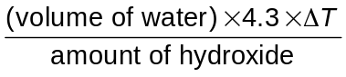  where amount of hydroxide = 